Name and Surname: Maciej Hryc

Practical tasks (we highly recommend to start working on the project from these questions during the classes)
[each task = 20 pts]
1. Paste here the RMSD plots of your production simulations for WT and MUT protease and state if your systems reached equilibrium (comment also on energies, temperature, density, etc). If so, indicate when it was reached and what the indicators were; otherwise, explain what are the following steps to reach the equilibrium.
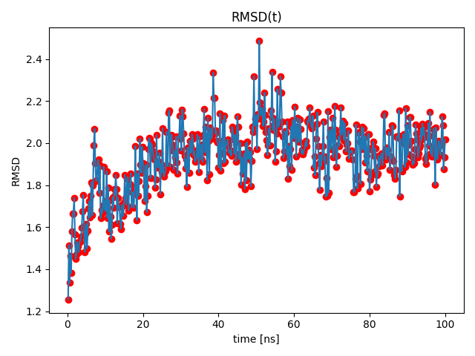

2. Paste the RMSF plots of the WT and MUT protease from your production simulations and explain: is there any difference between these two variants? If so, what are the differing regions, and what might be the reasons behind these differences? If there are no differences, plot both RMSFs in the same plot with different colors to support your conclusion that they are not different.
3. Comparing the binding affinity of Darunavir in WT and MUT protease, in which of these variants does the ligand bind better? You should use the results from hydrogen-bond analyses and the MMGBSA energy calculations. Providing a visualization of the protein-ligand complexes depicting these differences is highly recommended. Your answer should clearly state which of the protein variants is predicted to bind better based on your results and how your data supports them.
General/theory-based questions (suggested to complete them as soon as possible)
[each task = 10 pts]
1. What are the stages of ligand parametrization for molecular dynamics (MD) simulations? Why is this step crucial if you want to study protein-ligand complex using MD and why can one not simply use ligand structure from web databases?
2. How do you prepare protein for MD simulation? List the particular steps and briefly (1-2 sentences), explain the crucial goal of each particular step.
3. Enumerate the stages of a common MD simulation (consistently with the protocol that you have used during our practical classes). Briefly explain what happens in each stage, and which metrics/properties must be evaluated after each stage.
4. What represents RMSD and RMSF metrics in the context of protein dynamics? What type of information you can obtain with these metrics?

5. Define restraints (all relevant parameter settings) for minimization of WT system that would follow the minimization performed in practicals for the following scenarios: [optional task = extra 10 pts]
- heavy atoms of protein and ligand restraint force of 50 kcal/mol/Å²
- backbone atoms of protein and heavy atoms of ligand with restraint force of 10 kcal/mol/Å²
- backbone atoms of protein only with restraint force of 5 kcal/mol/Å²
- no restraints

